Part 1:

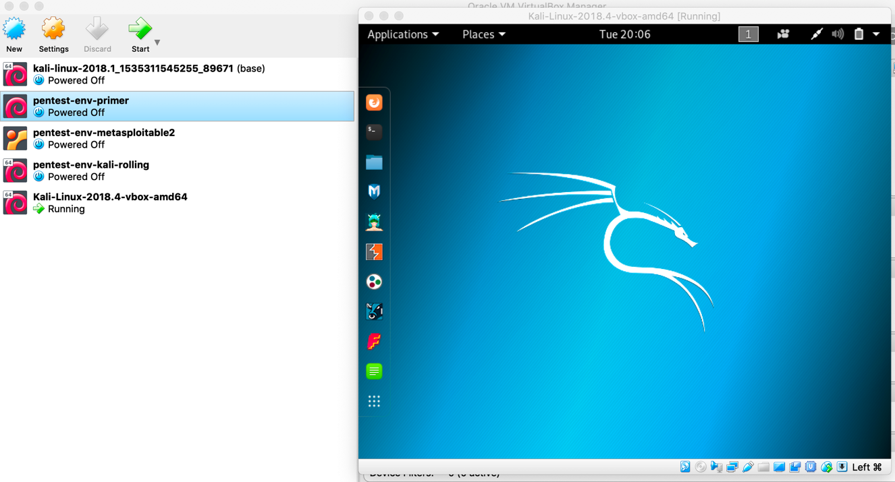

Part 2



Part 4

a.    (1) Start a recording script using the command script hw1.txt

b.     (1) First things first, we’ll confirm your user is in the sudo group by using

 grep sudo /etc/group

(If you don’t see your username as part of that output, you did not successfully add your user to sudo.)

c.     (1) Change directory to / using cd

d.    (1) List the files in / using ls

e.     (1) Change directory into etc

f.      (2) **What happens when you cd to the directory ..? What if you change to the directory . ?**

**cd ..** is leading user move back one directory. If your current directory is src/home/document/file1, then your new directory is src/home/document after running “cd ..” command line. “**cd .**” won’t let you change directory.

g.     (2) **How do you automatically change directories back to your home directory?**

Running “cd ~” command line to go back to home directory.

h.     (1) **What does pwd do?**

Check your current directory

1. (2) **What is the difference between ls and ls -a ? (hint: try this in your home directory)**

ls : list the contents in the current director,

ls -a : display all of the information of the content in that current directory. Include directory entries whose name begins with a dot. .

j.      **(1) What is the difference between ls and ls -F ? (hint: try this in /)**

Running “ls -F” will add “/” and “@” at the end of each file.



k.     (1) Create a directory in your home directory named hw1 using mkdir

l.      (2) **Change directory to hw1; what does**

**echo “cat a ton ic” > foo.txt do?**

Input a line of string in the foo.txt file.

m.  (1) Make a copy of foo.txt and name it bar.txt using cp

n.    (1) Make a directory inside of hw1 and call it hw1q

o.     (1) Copy foo.txt and bar.txt into hw1q

p.    (1) Remove bar.txt from the hw1 directory using rm

q.     (1) Move bar.txt from the hw1q directory into the hw1 directory using mv

r.      (1) Remove the hw1q directory and all of its contents using a flag with rm

s.     (2) **What does cat foo.txt do?**

It will display content in text file on the screen

t.      (2) **What is the difference between cat and less? (hint, try cat /etc/passwd and less /etc/passwd)**

**cat** :  It can be used to join multiple files together and print the result on screen, but it will not show page by

page.

**less** : You can navigate the page up/down using the less command and not possible in more command. And you can also you can also search a string in less command or modify the content.

u.    (2) Your Kali Linux distribution conveniently has the firefox browser installed. Invoke it from the terminal by entering firefox **Are you still able to enter commands at the terminal prompt? (why not?)**

I was not able to enter commands at the terminal prompt, because the terminal will be locked when we are trying to run applications from Terminal.

v.     (2) We call a running program a job. You can suspend a job by typing ctrl-z in the terminal window. Try it. **Can you still use firefox? Can you enter commands at the terminal?**

Yes, I can still using Firefox and enter commands at the terminal as well.

w.   (2) Ideally we can start jobs, keep them running, and also use the terminal for more commands. After suspending a job, the bg command does this. Try it. **Can you use firefox?**

Yes, bg is a job control command that resumes suspended jobs while keeping them running in the background.

x.     (2) **Quit firefox. Now start it again but using the command firefox & Explain what the & does.**

With & we can start application in the background and still use the terminal.

y.     (2) Connect to Canvas and download [glhw1.tar.bz2](https://canvas.xavier.edu/courses/42475/files/4241992/download?verifier=qDSdSwq93M3huNrIIQYBOyijuqLvOddzxtvlt42P&wrap=1) to your home directory. Expand it. **What has shelf life? Why don’t we know if the cake is a lie?**

﻿Potential has a shelf life 

Schrodinger’s cake is sometime a lie.



z.    (1) Finish the script you started way back in h by hitting ctrl-d Turn in the script file and your answers to the questions as part of your homework.